Issue 1: The displayed graph is wrong
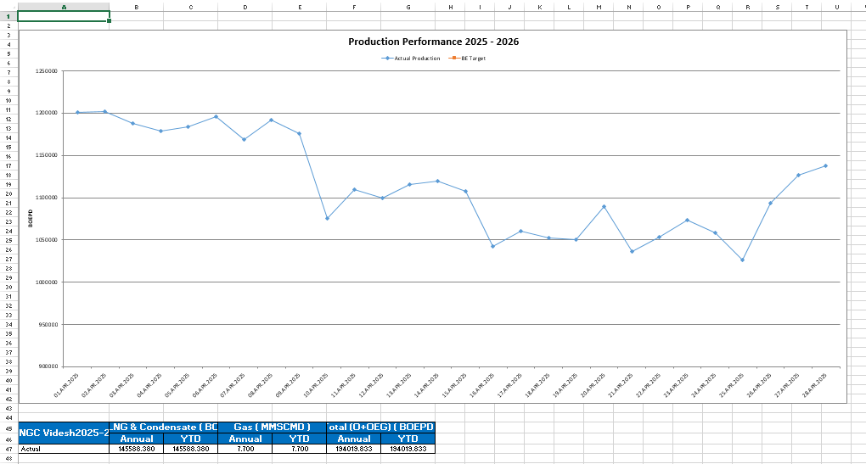

The values for each day should be near to 1 lakh as shown in annual average actual value, but the graph displays values nearing 12 lakhs.
Moreover the table displayed below the graph is inaccurate. Some of the fields have been omitted and the graph does not have the line graph for BE Target.
Previously run DPR Report:
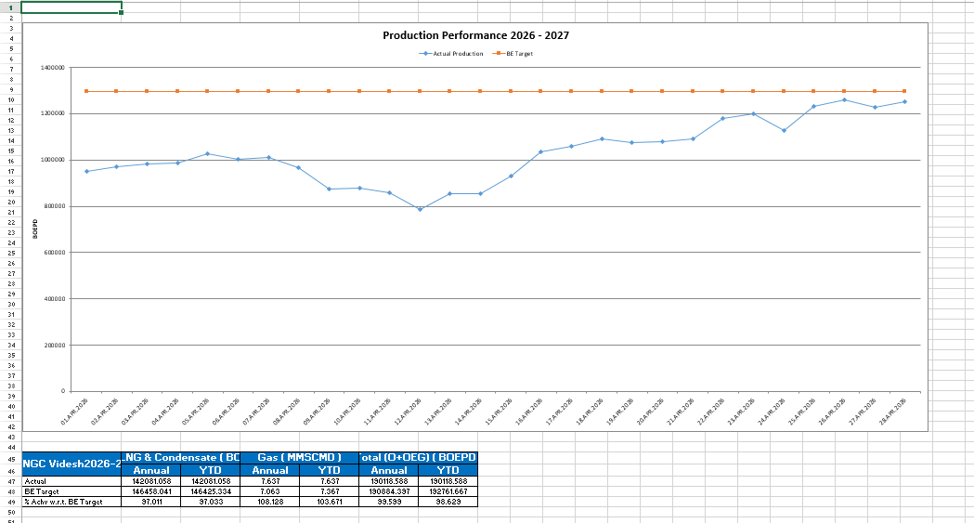

Issue 4: Output for the new report created:
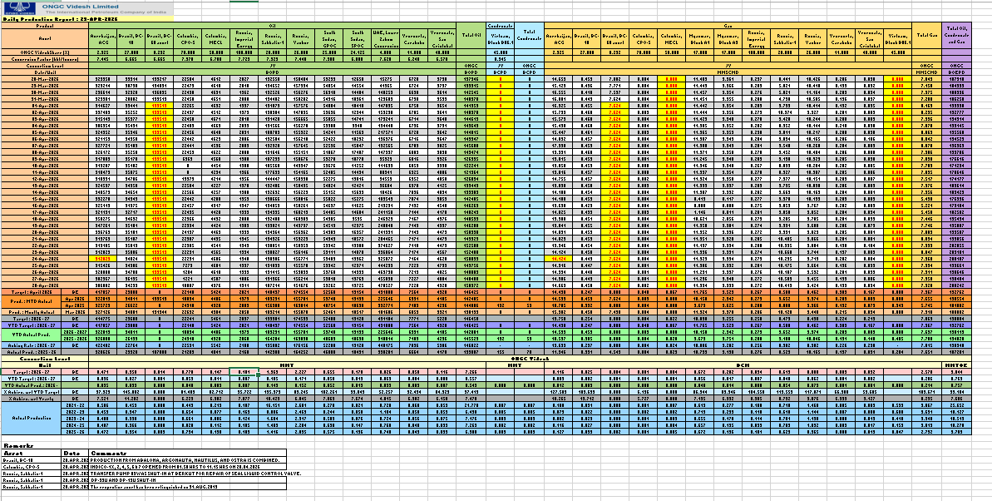

The actual production value of Russia, Sakhalin-1 for FY 2021 – 2022 is displaying as 16.151 but the correct value according to five year production report should be 2.183. The output in the new program is exactly the same as it was showing previously , no corrections.

DPR Report:
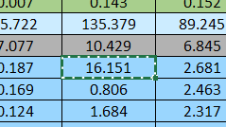
5 year production report:
